

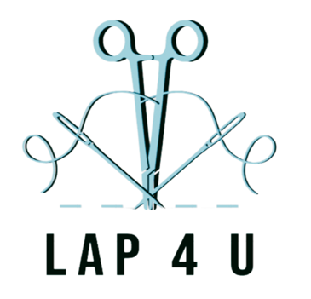




ADVANCED LAPAROSCOPIC TRAINING COURSE
FRIDAY 22nd May 2026 PROGRAMME

08.30 – Registration and refreshments
09.00 – Welcome and introduction to the course
09.10 – Laparoscopic anatomy of the female pelvis – Ms Mez Aref-Adib, Whipps Cross Hospital
09.40 – Laparoscopic entry techniques – Ms Victoria Sampson, North Middlesex Hospital
10.10 – Principles of electrosurgery – Ms Shital Sawant, Newham Hospital
10.40 – Management of bladder/vascular injures – Ms Rebecca McMurray, Whipps Cross Hospital
11.00 – Coffee/tea break
11.15 – Laparoscopic myomectomy - Mr Funlayo Odejinmi, Whipps Cross Hospital
12.00 – Robotic myomectomy – Ms Mez Aref-Adib, Whipps Cross Hospital
12.45 – vNOTES hysterectomy, salpingectomy, ovarian cystectomy – Mr Wai Yoong, North Middlesex Hospital
13.30 – Lunch provided
14.00 – Delegates rotate in pairs to each of 11 practical stations
17.00 – Close

