Requirements to be a BSGE Accredited Centre
Severe Endometriosis should be treated in specialist centres and the BSGE will accredit centres where gynaecologists work in appropriate clinical teams, audit their outcomes and have sufficient workload to maintain their surgical skills. The requirements to be a BSGE Accredited Endometriosis Centre are:

1. Consultant Gynaecologist(s) with appropriate specialist training and expertise to provide care for severe endometriosis.
There should be a lead consultant gynaecologist or team of gynaecology consultants who run the service and these will be the named consultants accredited to run a BSGE Endometriosis Centre. The consultant gynaecologists should be members of BSGE.

Gynaecologists specialising in the surgical treatment of complex endometriosis should have achieved specialist training in advanced minimally invasive surgery. This can be attained by:
- Completing RCOG recognized advanced laparoscopy training modules (ATSM / SITM) or
- Equivalent post graduate university degrees (eg. MSc in Advanced Gynaecological Endoscopy) or
- An equivalent fellowship for a minimum of 2 years under an experienced gynaecologist in advanced minimally invasive surgery in an endometriosis centre or
- An experienced gynaecologist who is already working in an endometriosis centre with a proven track record or
- Obtaining equivalent training under a senior gynaecologist in performing complex endometriosis surgery in a specialist centre.

2. Endometriosis Clinical Nurse Specialist
Having an Endometriosis CNS is a requirement and improves the quality of the service for the patients. Specialist nurses can carry out primary patient contact to triage referrals, collect patient symptom questionnaires and perform selected patient follow up appointments.

Endometriosis specialist nurses will ideally be at least Band 6 or above, but this is subject to local arrangements. For centres that submit up to 24 cases per year it is acceptable to have 0.5wte or more (whole time equivalent) clinical nurse specialist time. For centres required to submit more than 24 cases annually it is expected that increased specialist nursing time is required, ideally minimum 1 wte.

Endometriosis specialist nurses should be encouraged to participate in professional development (CPD) within the field of endometriosis. For example the CNS could attend the BSGE nurses’ day or BSGE Annual Scientific Meeting or attend suitable webinars or other appropriate on line training or courses. Commitment to Specialist Nurse CPD must be demonstrated as part of the annual re-accreditation process.

3. Supporting Colorectal Surgeon
A named colorectal surgeon is required to support the service. It is expected that he/she will contribute pre-operative clinical reviews, MDT discussion input and attend complex surgery involving the bowel and operate with the centre’s gynaecologists. The partnership will allow patients to receive the best advice, surgery and follow up where the pathology extends to the bowel.

A maximum of two named colorectal surgeons are allowed (and encouraged) for centres with up to 36 database cases. Beyond 36 cases a third colorectal surgeon can be named. The reason for placing a limit on number of colorectal surgeons is that they will not be involved with all the theatre cases entered on the database, yet keeping up an adequate number of surgical endometriosis cases is also important for the colorectal surgeons to maintain expertise in this specialist area.

4. Other supporting clinicians
A support network is required which includes urologists and pain management specialists who declare that they will provide active support to the service when needed. This may involve intra-operative support or outpatient support. It is expected that the names of consultants from these specialties will be recorded on the centre’s staff list. It is expected that every BSGE centre will have the following named individuals in addition to the Gynaecology endometriosis specialists and Colorectal surgeons:
- Urologist
- Radiologist
- Fertility Specialist
- Pain Specialist

5. Multi-disciplinary Team Meetings (MDTs)
To be an accredited centre the service must have scheduled MDT meetings which are expected to be planned at least monthly and should take place a minimum of 8 times per year. The MDT meetings should include a core membership of:
- All gynaecologists listed within the centre
- Endometriosis clinical nurse specialist
- Colorectal surgeon
- Radiologist
Other members can join meetings to discuss specific cases as required.
The MDT meetings should recorded outcomes that are communicated with patients and GPs.

6. A dedicated consultant lead specialist endometriosis outpatient clinic
This is a clinic, which is specifically devoted to endometriosis patients and accepts referral for this named condition. Ideally, it is recorded as such for any respective referrer; whether they be primary or secondary care clinicians. The clinic should have the word ‘Endometriosis’ in the title of the clinic with locally agreed referral criteria. The purpose is to ensure local patients and clinicians are aware of the specialist clinic and the advantages it will offer them. The clinic should run at least monthly, but in many centres such clinics will be required much more frequently

7. Workload
It is essential that there is sufficient workload throughput to maintain surgical skills for the most complex cases. Whilst all degrees of severity of endometriosis may be treated within the service, it is a requirement for each surgeon to have at least 12 cases of deep endometriosis invading bowel, bladder or ureter according to Enzian classification (see below), treated by surgery each year. This is 12 cases per gynaecological surgeon annually. So the accreditation for a centre with one named gynaecologist will be 12 cases, whereas a centre with two named gynaecologists will be 24 cases, with three gynaecologists 36 cases etc.

An index case is defined by a procedure to remove disease that is graded on the #Enzian grading as A1-A3 and / or C1-C3 and /or FB and /or FU and/or FI (ie deep disease affecting rectovaginal space, rectum, bladder, ureter or intestines). The cases must be recorded on the BSGE database to qualify as an index case. Whilst this can include open surgery it is expected that this will usually be undertaken laparoscopically.

8. Data collection
An agreement from the lead gynaecologist in the Centre that all cases of surgical excision of DEEP endometriosis affecting rectovaginal space, rectum, bladder, ureter or intestines will be entered on to the database, and will be followed up for at least 12 months following surgery.

The index cases to be entered on that database should include any cases fulfilling the #Enzian grading as A1-3 and / or C1-3 and /or FB and /or FU and/or FI (ie deep disease affecting rectovaginal space, rectum, bladder, ureter or intestines).

All patients must give written consent to be added to the BSGE database and have completed baseline symptom and quality of life questionnaires. It is expected that every centre will achieve follow up questionnaire rates, entered on the database - 70% at 6 months and 60% at 12 months. If centres choose to collect follow up data at 24 months this can also be entered on the database but is not mandated.

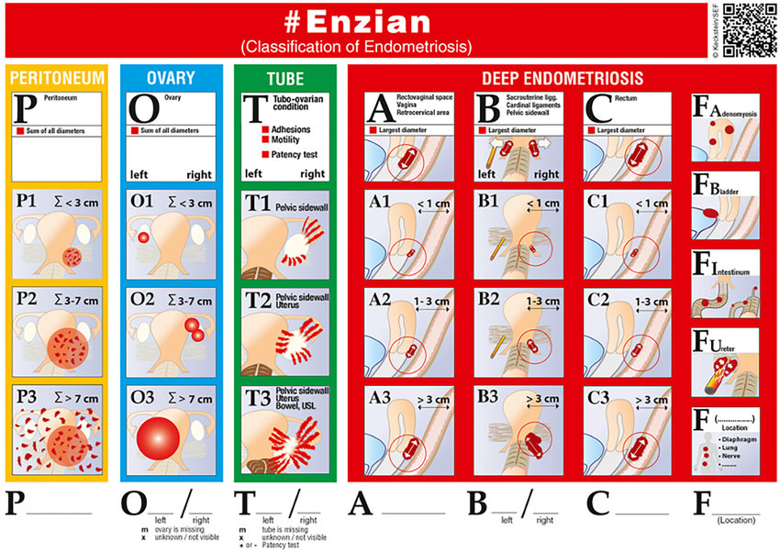
9. Service sustainability and resilience
The BSGE wishes to ensure that patients suffering with endometriosis are treated as effectively and consistently as possible. It is important that the service is resilient to periods of sickness, extended leave or retirement within the surgical team. Every centre must demonstrate that there are plans for service sustainability at each annual re-accreditation. Failure to do this may jeopardise re-accreditation.

10. Compliance with BSGE quality assessment
To ensure the quality of surgical care provided within BSGE centres centres are expected to:

- Provisional Centres will need to submit exemplar videos for each registered gynaecologist before 31st December of their ‘Provisional’ year. The videos will need to fulfil the following criteria:
  - Maximum 3 minute normal speed completely anonymized video (with centre number at start of video).
  - Case of deep infiltrating endometriosis affecting rectovaginal space – demonstrated by panoramic view at start of video.
  - Demonstration of deep pararectal dissection and complete excision of disease – demonstrated by panoramic view at end of video.
  - Case should NOT involve a hysterectomy as these are difficult to assess complete resection

(NB – from 2025 there will no longer be an annual video submission from accredited centres unless quality concerns have been raised for other reasons)

- Inclusion of ‘before’ and ‘after’ still surgical photos of deep disease for at least 50% cases on database (reviewed at random by the Scientific Advisory Group at time of re-accreditation)

- Review of outcome data and complication rates (reviewed at random by the Scientific Advisory Group at time of re-accreditation)

