Mr

Application Form

UK Total Gynaecology Robotic Hysterectomy Surgery Conference and Cadaveric Hands On Dissection Course

10-11 June 2019

NEWCASTLE SURGICAL TRAINING CENTRE



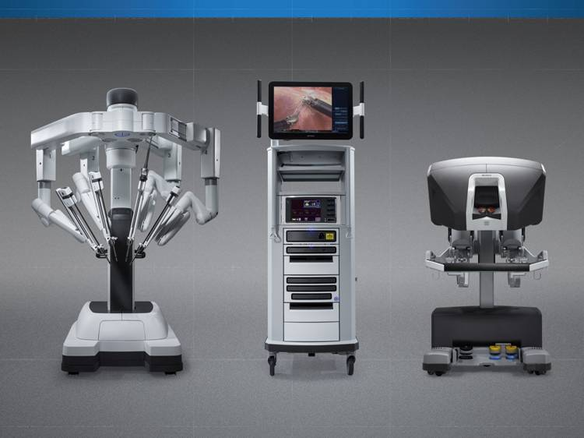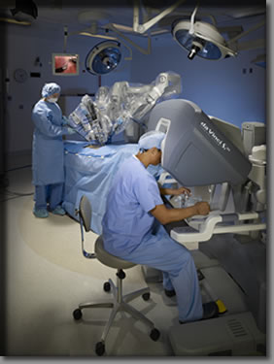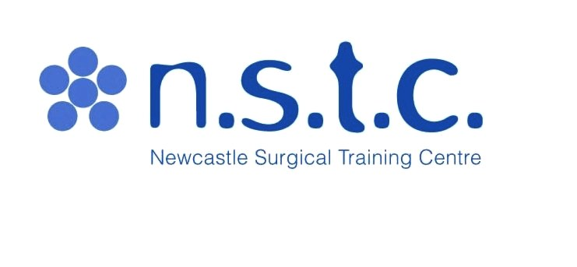

**Newcastle Surgical Training Centre** delivers over 170 advanced training courses from regional, national and international surgeons representing multi specialties. Collaboration with national and international faculty drives a greater understanding of surgical techniques delivering improved patient care.

**www.nstcsurg.org**

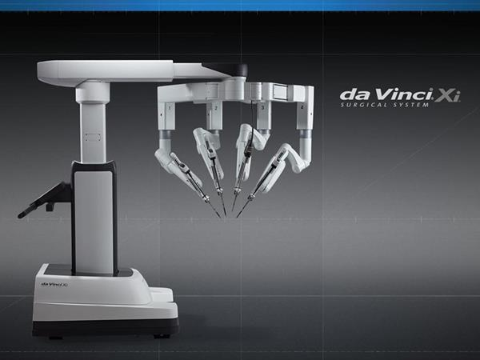

About the centre

**FACULTY**

**UK FACULTY**

**Mr Tony Chalhoub, Consultant, Newcastle Trust**

**Additional faculty to be confirmed**

Further information

For full details and registration information visit www.nstcsurg.org

Or contact: Louise Sore

Freeman Hospital, Newcastle upon Tyne

Tel: (+44) 0191 213 8589

Email: louise.sore@nuth.nhs.uk

**www.nstcsurg.org**

**Newcastle Surgical Training Centre**

At the Newcastle Surgical Training Centre we are committed to giving you the best possible opportunities in education and training by offering a wide range of multidisciplinary courses to meet your every need. Our highly professional clinicians are here to train and support you every step of the way. Combining didactic teaching and practical procedures with leading edge technology, we offer first rate cadaveric training and continuing professional development in a purpose built facility. We also carry out pioneering research into new techniques and ensuring that you receive the very best surgical training available in the UK, both for today and in the future.

The Newcastle Surgical Training Centre is led by the co-directorship of Professor Alan Horgan and Professor David Deehan. The centre delivers over 170 advanced training courses from regional, national and international surgeons representing multi specialties. Collaboration with national and international faculty drives a greater understanding of surgical techniques delivering improved patient care.



Course Objectives

NON DISSECTORS- clinical lectures

* Define the role of robotic surgery in current day
* Appreciate the strengths and weaknesses of the evidence base in this emerging field
* Share best practice on setting up a robotic surgery programme
* Understand the benefits and rationale of offering a total robotic hysterectomy in complex benign and gynaeoncology

DISSECTORS – Full access to the Xi Da Vinci Robot – with hands on procedures on fresh frozen cadavers and full access to the clinical lectures

* Become familiar with the function and operation of the da Vinci Surgical System
* Appreciate the ergonomics of the da Vinci Surgical system robot and the available robotic instrumentation
* Understand the selection process for patient position, da Vinci surgical team position and robotic surgical approaches
* Learn robotic tissue dissection techniques using bipolar and monopolar energy
* One to One radical robotic hysterectomy on fresh frozen cadavers

**CPD PENDING**

**Target Audience – Gynaecologists**

**& Gynae-Oncologists**

**This course is designed to facilitate the surgeon with didactic and hands on cadaveric training experience, conducted by a faculty of robotic experienced surgeons. This is a 2 day course of lectures, live surgery, practical one to one hands on cadaveric robotic surgery using Xi DaVinci Robot.**

* **2 day Intensive course**
* **Number of Dissectors limited to 8**
* **Non-Dissectors (full access to clinical lectures and simulator only)**

**COURSE CONTENT**

**Live Surgery link to Theatres**

**Review of Clinical Evidence**

**3rd Arm Utilization**

**Port Placement Review**

**Docking with SI and XI**

**Importance of Patient Selection**

**Left & Right Sidewall Dissection (Cadaveric)**

**Hysterectomy (Cadaveric)**

**Suturing (Cadaveric)**

**Anaesthetic considerations**

Course overview

**www.nstcsurg.org**

**Newcastle Surgical Training Centre**

UK Total Gynaecology Robotic Hysterectomy Surgery Conference and Cadaveric Hands On Dissection Course

|  |  |  |  |
| --- | --- | --- | --- |
| Course options (please indicate accordingly) | | | |
| DISSECTOR FEES  **£1200.00 (discount for BIARGS members @ £975)** | | |  |
| NON DISSECTOR FEES  £295.00 | | | |
|  |  |  |  |

|  |  |
| --- | --- |
| Your details | |
| Surname: | Title: (Mr / Mrs / Miss / Ms ) |
| Forenames: | |
| Job Title: | Department: |
| Hospital Address: |  |
|  | Postcode: |
| Mobile Telephone: | Email: |

|  |
| --- |
| Further details |
| How did you hear about this course? Trust Website Mailing Other |
|  |
| Please state any special dietary requirements: |
|  |

|  |  |
| --- | --- |
| Declaration | |
| Signed: | Date: |

     

     

     

Please note: The course fee will include: lunch and refreshments. Payment can be made via BACS (automatic bank transfer) by Credit Card, or by cheque payable to Newcastle upon Tyne Hospitals NHS Trust. Full details and registration information at www.nstcsurg.org Please note payment is due at registration to secure your place. Attendance on the course is conditional upon advance payment being received. Refunds cannot be given in the event of your cancellation within two weeks of the course date. The NSTC cannot accept liability for costs incurred in the event of a course having to be cancelled as a result of circumstances beyond its reasonable control. There is an administration charge of 10% (or £50, whichever is greater) of the total course fee. However, within four weeks prior to the start date of the course, the total course fee will be charged unless in exceptional circumstances at the discretion of the NSTC.

While we make every effort to run courses as advertised, we reserve the right to change the timetable and/or the teaching staff without prior notice and to cancel any courses without liability (in which case there will be a full refund of course fees to participant). Note that any consequential losses (e.g. travel or accommodation costs) incurred in such cases remain the responsibility of the booker, and consideration should be made to taking out appropriate travel insurance for any non-refundable costs.

     

|  |  |
| --- | --- |
| **https://webmail.nuth.nhs.uk/WebMail/Lorraine.Waugh/Inbox/NSTC%20logo%20and%20spotlights.EML/1_multipart_xF8FF_3_multipart_xF8FF_1_n.s.t.c._logo.jpg/C58EA28C-18C0-4a97-9AF2-036E93DDAFB3/n.s.t.c._logo.jpg?attach=1**  **BACS DETAILS**  Newcastle Upon Tyne Hospitals NHS Trust  Bank Details for Transfer of Money. | |
| **Bank Name** | **HSBC Bank** |
| **Bank Address:** | **110 Grey Street**  **Newcastle upon Tyne**  **NE1 6JG** |
| **Sort Code:** | **40-34-18** |
| **Account No.:** | **41763709** |
| **Account Name:** | **NUTH No.1 account** |
| **IBAN No.:** | **GB26HBUK40341841763709** |
| **BIC code** | **(BIC11):HBUKGB4108J** |
| **VAT No:** | **654 9687 77** |
| **Reference:** | **SURGTRAINING** |